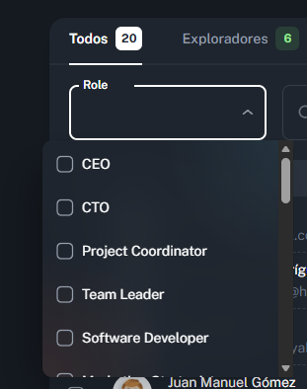
Incompleto, verse:
member_list_view.jsx
Importar
import { _memberDivisions, _memberList, MEMBER_STATUS_OPTIONS } from 'src/_mock';

if (role.length) {
inputData = inputData.filter((member) => role.includes(member.memberDivision));
}

<MemberTableToolbar
filters={filters}
onResetPage={table.onResetPage}
options={{ memberDivision: _memberDivisions }}
/>

const filters = useSetState({ name: '', memberDivision: [], memberStatus: 'all' });

member-table-toolbar.jsx
{options.memberDivision.map((option) => (
<MenuItem key={option} value={option}>
<Checkbox
disableRipple
size="small"
checked={currentFilters.role.includes(option)}
slotProps={{ input: { id: `${option}-checkbox` } }}
/>
{option}
</MenuItem>

updateFilters({ memberDivision: newValue });

Crear en \_mock\_mock.js
memberDivision: (index) => _memberDivisions[index],

src\_mock\assets.js
export const _memberDivisions = [
'Exploradores',
'Seguidores',
'Pioneros',
'Navegantes',
];

